Studio Practice Game Design Report

Contents

Given Briefs 1

Initial Game/ App Idea 2

Final/ Chosen Idea 2

Adding Gamification 2

Research towards App Avatars 2

Designing the Avatar 4

Avatar Base 4

Avatar Features 4

Eyes 4

Mouth & Hair 4

Arms & Hands: 5

Customisation Assets: 6

Sun Glasses: 6

Cap/ Snapback: 6

Challenges & What I’ve learned: 7

Modelling software: 7

Organic modelling: 7

Conclusion: 7

# Given Briefs

At the beginning of the project my group got our selection of project briefs which included interaction within games, services for museums, augmented reality based and healthcare related. After a couple group meetings as well as a simple voting system we went for a mobile gaming app towards transforming healthcare. We looked at both the given briefs and their requirements to see how we can merge them together to create a healthcare application.

## Initial Game/ App Idea

Once we got our idea of creating a mobile application towards “transforming healthcare” brief approved we got to work brainstorming potential ideas which would be combatable to the brief given to us. We came up with some ideas relating to food nutrition and weight loss programs but they have been done millions of times, so in an attempt to stand out for our vast competition our group looked into bringing augmented reality to the app.

## Final/ Chosen Idea

After a couple weeks’ worth of research towards current competitors and ow to stand out using augmented reality we chose to design the app around diabetes type 2 (Insulin one). This app will help the users track how much insulin they’ll need during the day and why they need it. This in the long term can help reduce the usage and improve the diets of the users.

This app also allows the users to scan any food and drink products by taking a photo of the item and the app will then show you its nutrition, its ingredients, rating out of five towards your current state and a photo of the product.

## Adding Gamification

Whist the group leader and UX designers researched into augmented reality and how we can include it into the application myself and our game animator where tasked to find a way to include gamification towards the app to help attract more users. We looked into ways previous apps of similar nature have tried to add this feature as well as software sure as Microsoft.

## Research towards App Avatars

Based on our initial research we learned that players do not like to have a character on their screen which has no purpose such as the paperclip from Microsoft Word so we chose to create a simple survey on Survey Monkey to get some results from the general public what they would like to see in a nutrition app. Results are shown below:

From these five questions I and our games animator decided to create a game avatar with either a characteristic of an animal or a fruit. It would be designed in the realistic theme, have a progression or levelling up system, and will be suitable for adults in the range of 18-34 with an audio system included. This is shown on figures 1-5 below

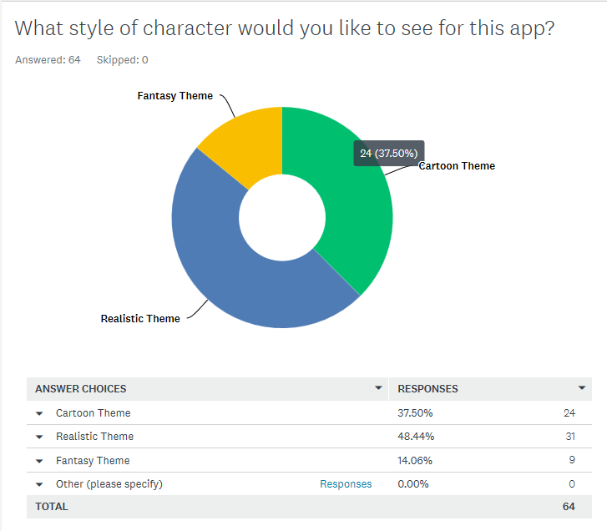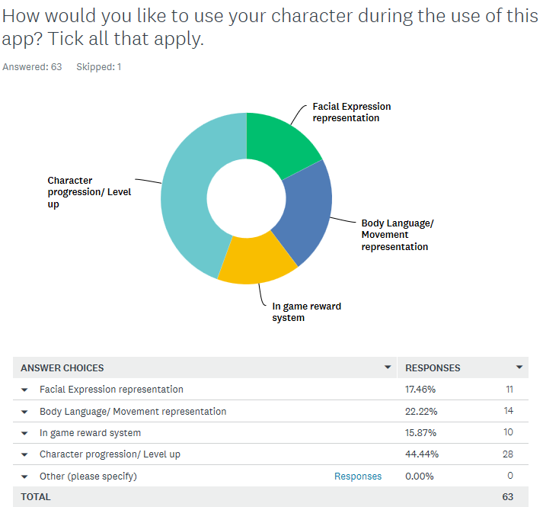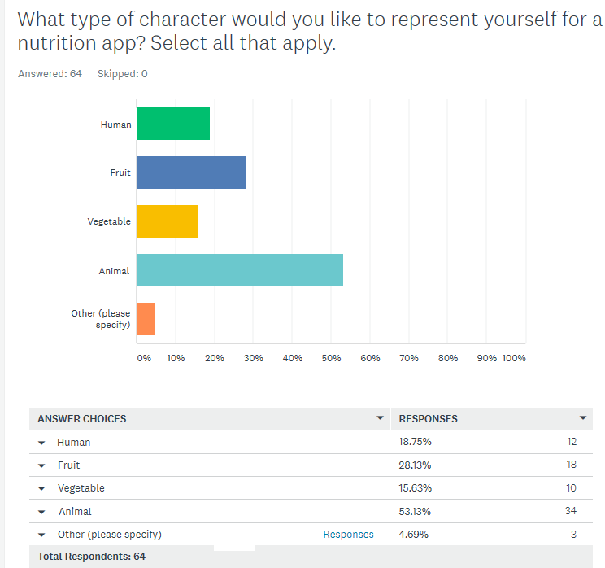

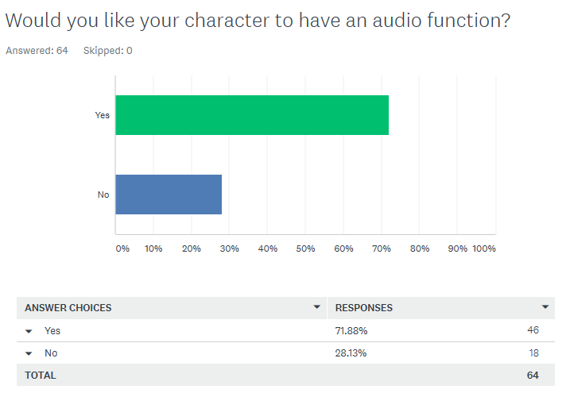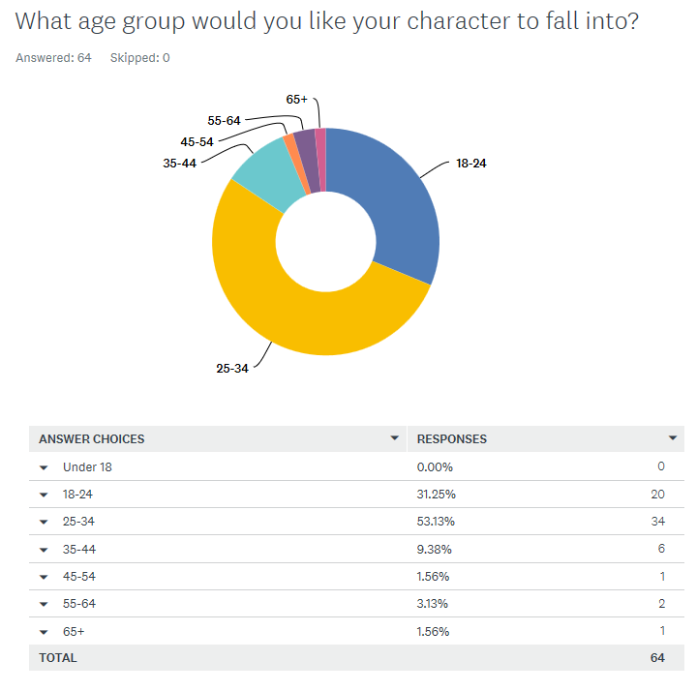

Figure -5

# Designing the Avatar

Using the survey data received, as a group we decided to create an avatar using a fruit base form with realistic facial and clothing features. This is due to myself not being able to 3D model animals to well and wished for this feature to encourage players to keep using our app. We did some research towards potential designs by showing mood boards and current avatars in animated movies. After this, we chose to create a realistic styled Avocado with human like features such as arms, face, hair and a chest.

## Avatar Base

The software I used to create the avatar was Maya 2019 due to it being easier to use its available tools to animate the character once it was complete. To create the base of the avocado I used a sphere and then stretched out the top half and width at the bottom half to give the impression of the top and bottom part of the body. Then the model was cut in half and attached the nutty chest on the lower third of the body. This is shown in figures 6-8

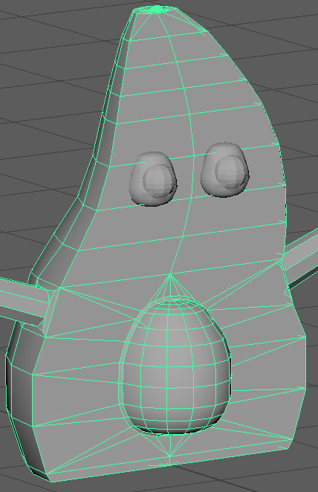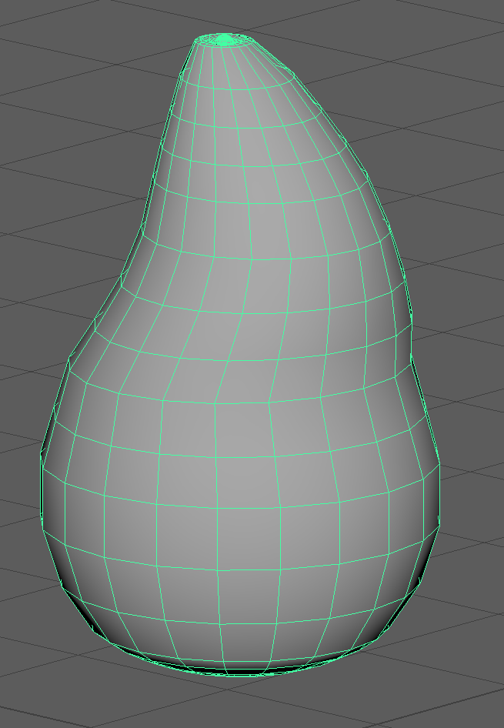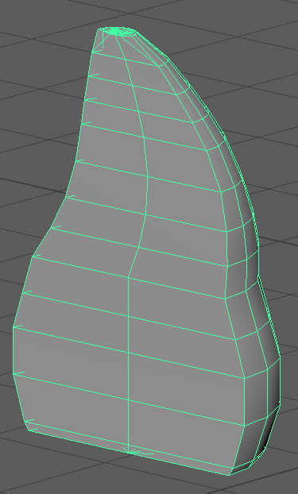

Figure 6-8

## Avatar Features

### Eyes

After completing the base body of the avatar the facial features and arms were created. To complete the eyes another sphere was created and shaped using the body nut as a guide, then it was duplicated. Using the scale tool it was reduced in size to create the eyelids and placed them in between the eyes and body and attached the two spheres to create the eye and pupils. To make it easier to animate me and our animator we decided to keep both elements of the eyes as two separate objects to then be exported together when required. This is shown in figure 9

### Mouth & Hair

The hair of the avatar was then designed, I decided to add a stem with a couple of leaves that would then be animated to move or whilst wearing head clothing would be squashed inside. I did this by using the extrude tool from the modelling options from the top of the model and adding several segments so the leaves could be added as well as bends so animations would be easier to create. The mouth was done by creating a box with several segments and a tongue once that was done the smooth tool was used and then the soft selection tool to create the curvy edges. This is shown in figures 10 & 11

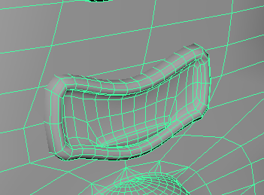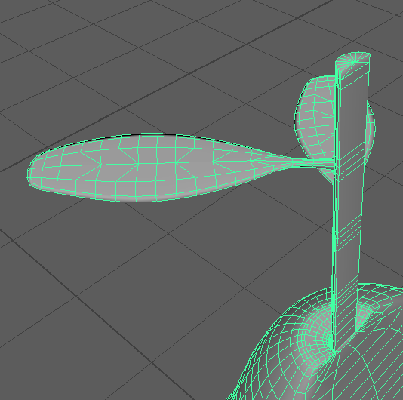

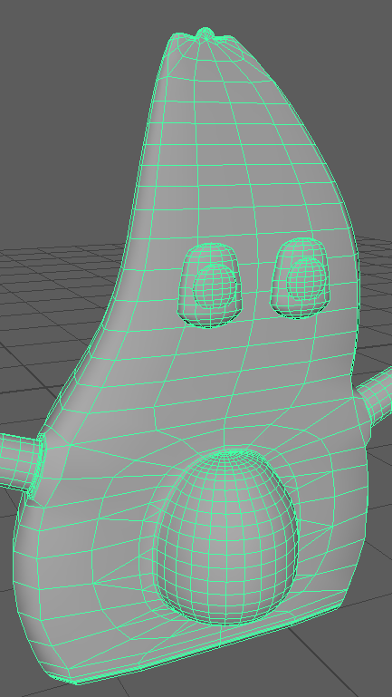

Figure 9

Figure 10, 11

### Arms & Hands:

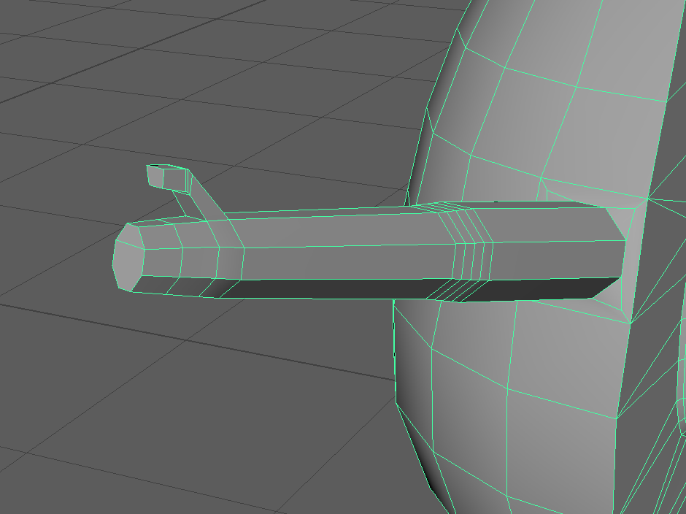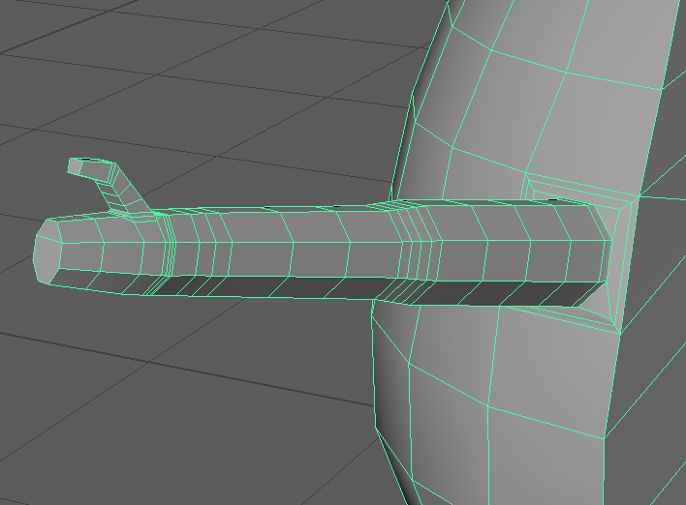The arms of the body was then designed, after some research I decided to use the same tools and methods I used to create the facial features. I made both sides of the arms into a six sided face and then extruded those outwards evenly. At the ends of each extruded arm I used the scale tool and connect tools to create the foundations of the hands. To create the hands the extrude tool was used once more for the thumb and mitten looking hand. Once complete the extra segments for the shoulders and elbows where created but using the connect tool to create more segments. This process is shown below on figures 12 & 13. After his process was complete the groups animator look the role of creating the arms due to these arms not being good enough for his animation processes.

Figure 12, 13

# Customisation Assets:

For my role as a game design I was also tasked to create customisation assets for the avatar. With these assets the player can make their avatar their own, bringing in more gamification and nurturing into the game. The assets I chose to create where a pair of sun glasses and a beanie.

### Sun Glasses:

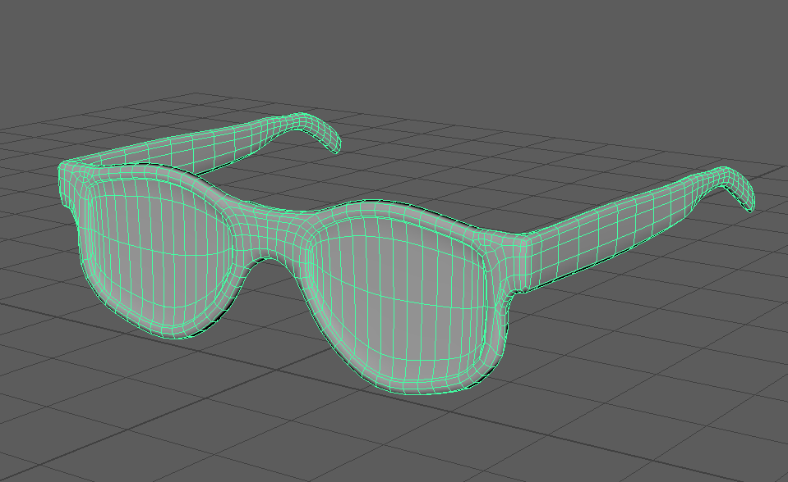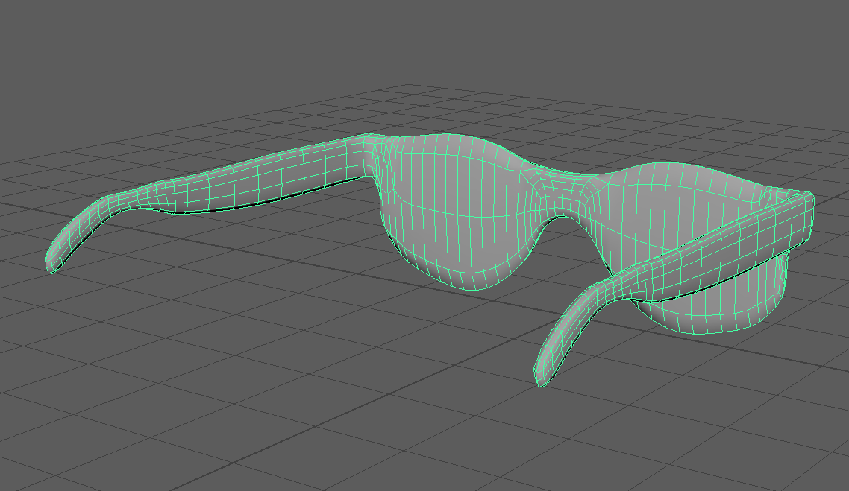The sunglasses where then designed by using the same methods of extruding, scale, connect, soft selection and smoothing tools. What I did differently was the accuracy of each side of the model making sure they are symmetric. I did this by using the snap to vertex tool and the “local translate Z” option under the extruding tool. This drastically helped keep the model symmetric. Then I finished off by smoothing the model with the smooth tool. Results are sown on figures 14 & 15 below.

Figure 14, 15

### Cap/ Snapback:

The cap or snapback where then designed by using the same methods of extruding, scale, connect, soft selection and smoothing tools. What I did differently here was the extra details and on the back of the cap to include a hole. To achieve this I used the multi cut tool which allows me to add free handed segments to the model. I used this tool to add the top rounded area of the cap and the whole at the back after deleting the faces and using the bridge tool to bridge the faces on the outer parts of the hole. The results are shown on figures 16 & 17.

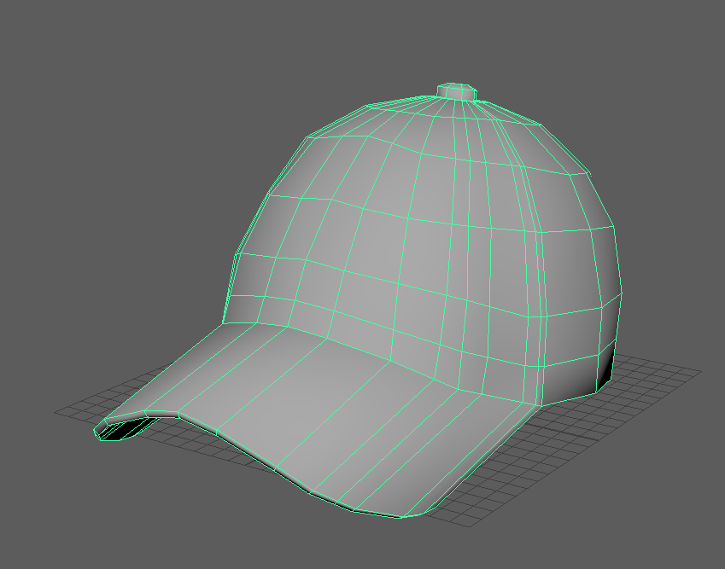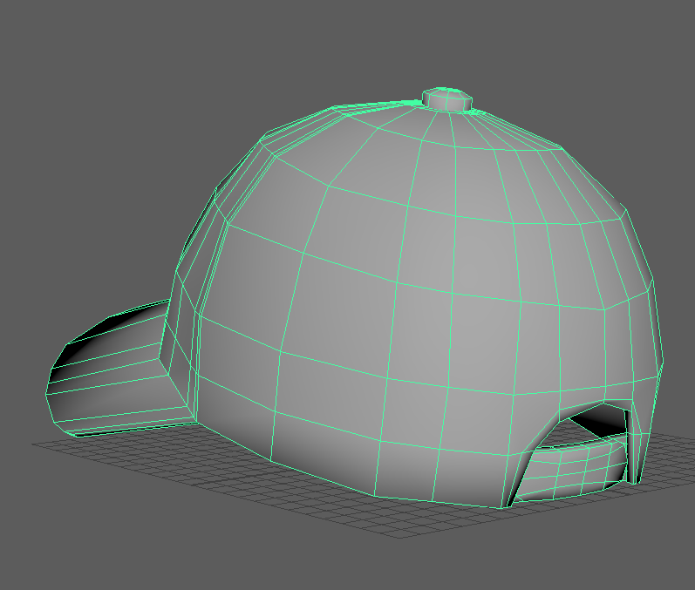

Figure 16, 17

# Challenges & What I’ve learned:

### Modelling software:

One of my main challenges in this module was the equipment to learn a new 3D modelling application being Autodesk Maya 2019. This software is similar to what I’m used to “Autodesk 3DS Max 2018” but is not the same, the main differences being where the tools are hidden in order for me to complete tasks effectively and on time. For the first month of the project I spent learning this software with the help of the groups animator, this also was very useful for my personal projects.

### Organic modelling:

My second main challenge in this module was the ability to model living/ organic objects. This is something I have never been good at. Nevertheless I trusted in my ability and willingness to learn new ways of modelling as well as things I can model, this did take and at times was holding the group back but the final product given was good enough to please everyone and felt pleased on what I have created.

# Conclusion:

My role and responsibility in this project is to design and model the player’s avatar as well as creating assets for the player to customise their character. We came up with this idea due to he failed attempts at avatar implementation in other apps, software programmes and games. Also too made sure all the assets are legal meaning they can be imported into 3D engines, in our case Unity seamlessly.

As a game designer, the role I had in this project is different to what I’m used to because the project demanded a set of skills which I have not used in years, but I was prepared to take on the challenge and learn in the process. I had a big opportunity to build on my current skills in modelling with the designs and implementation of this project.